FCC Forward Auction Gets $8.49B in 1st-Round Bids
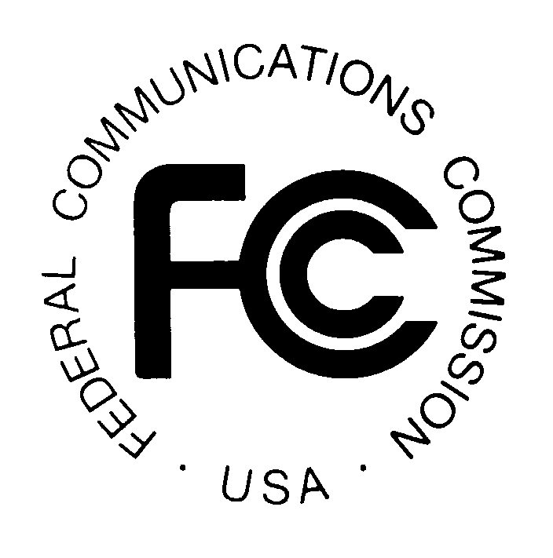
The Federal Communications Commission's forward auction of broadcast spectrum raised $8.49 billion in bids Tuesday. The FCC needs to generate approximately $88 billion in bids to cover the reverse auction, as well as broadcaster moving expenses.
Broadcasting & Cable 8/16/16
http://www.broadcastingcable.com/news/washington/849-billion-bid-fccs-forward-auction-opening-round/158871

