FCC Implements Broadband Labels
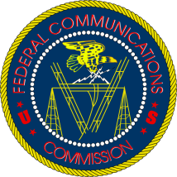
Internet service providers will have to start displaying prices, fees and speeds for their service now that the FCC has approved label requirements. Labels have to be accessible and appear on ads, websites and other marketing materials, though they're not required on monthly bills.
Next TV/Multichannel News 11/17/22
https://www.nexttv.com/news/fcc-approves-broadband-label-rules?utm_term=A25693A1-51B6-4112-BDE4-56BD420E983F&utm_campaign=3E572E13-3FBC-11D5-AD13-000244141872&utm_medium=email&utm_content=926DB39B-EE8B-419E-BA5E-D213DBD4308F&utm_source=SmartBrief

