FCC Authorizes $26.5B T-Mobile-Sprint Merger
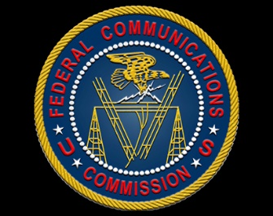
The Federal Communications Commission has formally approved a $26.5 billion merger of T-Mobile and Sprint, with all three Republicans supporting the decision and the two Democrats opposing it. A group of state attorneys general has sued to block the merger, and a trial is scheduled to begin Dec. 9.
TechCrunch 11/5/19
https://techcrunch.com/2019/11/05/fcc-approves-t-mobile-sprint-merger-despite-serious-concerns/

