FCC OKs Sinclair Purchase of 7 Bonten TVs
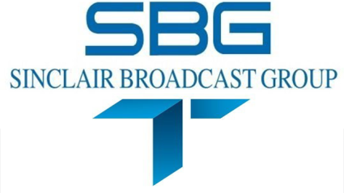
The commission also granted Sinclair's request that KCFW Kalispell, Mont., continue to operate as a satellite of KECI Missoula, Mont., under the satellite exception to the duopoly prohibition in smaller markets, those with fewer than eight independent voices.
TVNewsCheck 7.3.17
http://www.tvnewscheck.com/article/105374/fcc-oks-sinclair-purchase-of-7-bonten-tvs?utm_source=Listrak&utm_medium=Email&utm_term=FCC+OKs+Sinclair+Purchase+Of+7+Bonten+TVs&utm_campaign=FCC+OKs+Sinclair+Purchase+Of+7+Bonten+TVs

