FCC Opens Window For New Noncommercial FMs
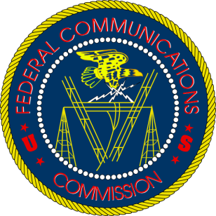
The filing window opened at midnight Eastern Time today (Nov. 2) as the Federal Communications Commission begins accepting applications for new noncommercial stations for the first time since 2007. While it is impossible to say how many applications will be submitted, the FCC has repeatedly said that it expects to receive a “large volume” of requests for licenses that fall between 88.1 and 91.9 FM.
Inside Radio 11.2.21
http://www.insideradio.com/free/for-the-first-time-in-14-years-fcc-opens-window-for-new-noncommercial-fms/article_f7543c02-3bab-11ec-be53-bba35d16ae39.html

