FCC Proposes Major Kids TV Rule Changes
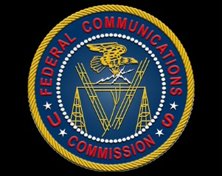
The FCC is tentatively proposing to eliminate a number of children's TV rules, and seeks comment on changing others, tentatively concluding that educational and informational programming does not have to be at least a half-hour in length and regularly scheduled.
Broadcasting & Cable 6.21.18
https://www.broadcastingcable.com/news/fcc-proposes-major-kids-tv-rule-changes

