FCC Proposes "Performance Requirements" for 5G
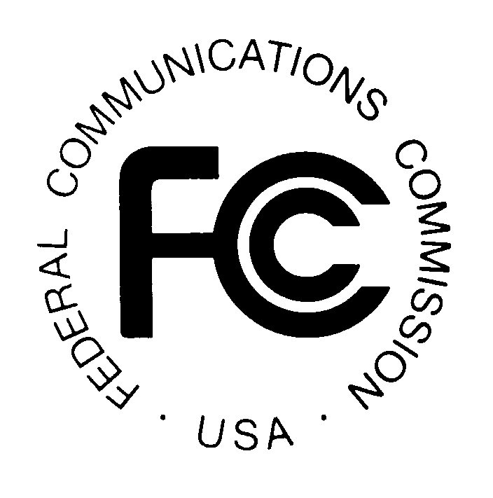
The Federal Communications Commission on Wednesday requested comments on proposed "performance requirements" for 5G service. The proposed rules focus primarily on cybersecurity, including requiring the submission of network security plans and ongoing participation in data-sharing programs.
FedScoop 8/24/16
http://fedscoop.com/fcc-proposes-5g-cybersecurity-requirements-asks-for-industry-advice

