FCC Puts 2-Week Hold on Sinclair-Tribune
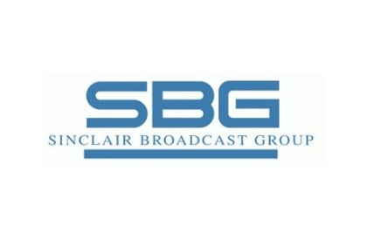
The FCC is pausing its review of Sinclair Broadcast Group’s proposed merger with Tribune Media to allow more time for the filing of public comments. The FCC is more than halfway through its 180-day timeline for review of the merger, which would create a broadcasting giant with 223 TV stations serving 108 markets. The FCC’s Media Bureau said it is pausing the review for 15 days until Nov. 2.
Variety 10.19.17
http://variety.com/2017/politics/news/fcc-pauses-sinclair-tribune-merger-1202593745/

