FCC Seeks Feedback On Raising LPFM Max Power Caps
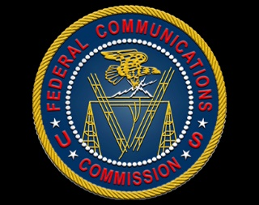
A petition from REC Networks has prompted the Federal Communications Commission to seek public feedback on a proposal to raise maximum power limits for low-power FM radio stations to 250 watts from the current cap of 100 watts. LPFM advocates are hopeful the FCC will approve the change, noting that the current cap limits stations' ability to broadcast more than a few miles from transmitter sites or into some buildings within that range, disadvantaging some local communities.
Radio World 6.8.21
https://www.radioworld.com/news-and-business/business-and-law/lpfms-are-hopeful-about-simple-lp250?utm_source=SmartBrief&utm_medium=email&utm_campaign=45863C53-9E40-4489-97A3-CC1A29EF491D&utm_content=9FB0AAF7-6AAC-4903-A9B1-305D39F162A1&utm_term=a25693a1-51b6-4112-bde4-56bd420e983f

