FCC Spectrum Auction Bidding Ends at $19.6B
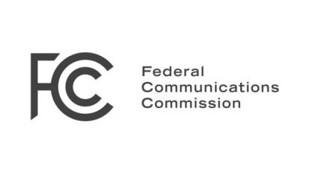
The Federal Communications Commission's wireless spectrum auction brought in bids totaling $19.6 billion, with $10 billion going to broadcasters, more than $6 billion to the US deficit and as much as $1.75 billion to repack costs. Though bids fell short of original estimates, former FCC Chairman Julius Genachowski says the auction was "an amazing success" that will generate investment and innovation.
Broadcasting & Cable 2/10/17
http://www.broadcastingcable.com/news/washington/genachowski-auction-was-amazing-success/163278

