FCC Starts Enforcing Rules Against Digital Discrimination
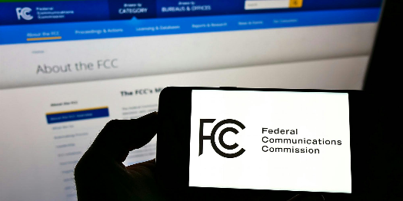
The FCC has started enforcing its rules against digital discrimination, has established a site where people can submit complaints, and notes that penalties include remedial orders and forfeitures. Broadband providers must give the FCC yearly reports about compliance programs and recent projects under the new regulations.
Fierce Telecom 3/25/24
https://www.fiercetelecom.com/broadband/fcc-rule-combating-broadband-digital-discrimination-goes-effect
Image copyright:
https://uploads.dailydot.com/2022/03/fcc.jpg?auto=compress&fm=pjpg

