FCC Targets Landlords In Pirate Radio Crackdown
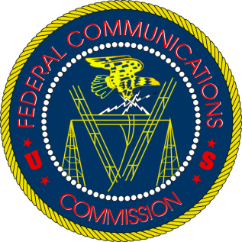
The Federal Communications Commission has notified a number of land owners that they could face hefty fines over pirate radio stations broadcasting from their properties. The agency has not yet revealed the success of its crackdown on illegal broadcasts, but has filed its annual report on the initiative with federal lawmakers.
Radio World 10.17.22
http://r.smartbrief.com/resp/pDeiDwljfllIaLsYaAcekIalPDxP?format=multipart

