Few Teens View Social Media As Negative
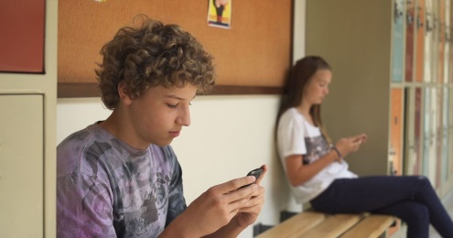
About one-third of teenagers reported having a primarily positive experience on social media, and 59% said it's not positive or negative, according to a Pew Research Center survey of US teens ages 13 to 17. Of those surveyed, 80% said social media makes them feel more connected, and 71% said social platforms give them a place to be creative.
Pew Research Center 11.16.22
https://www.pewresearch.org/internet/2022/11/16/connection-creativity-and-drama-teen-life-on-social-media-in-2022/
Image credit:
https://fntalk.com/wp-content/uploads/2018/09/cfntalkfoto636695206929989949-IMG-1506.jpg

