Finland Is Winning The War On Fake News.
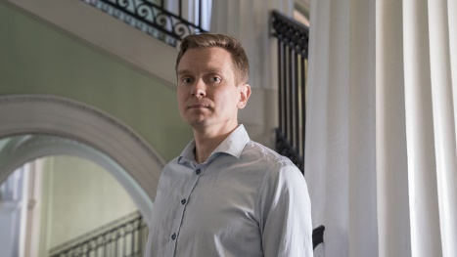
Standing in front of the classroom at Espoo Adult Education Centre, Jussi Toivanen worked his way through his PowerPoint presentation. A slide titled “Have you been hit by the Russian troll army?” included a checklist of methods used to deceive readers on social media: image and video manipulations, half-truths, intimidation and false profiles.
CNN 8.2.19
https://www.cnn.com/interactive/2019/05/europe/finland-fake-news-intl/?utm_source=Daily+Lab+email+list&utm_campaign=3b2583e4af-dailylabemail3&utm_medium=email&utm_term=0_d68264fd5e-3b2583e4af-396123901
Image credit:
https://abtshield.com/wp-content/uploads/2019/05/CNN00675-lg.jpg

