"First Informers" Law Will Be Put to the Test With Florence
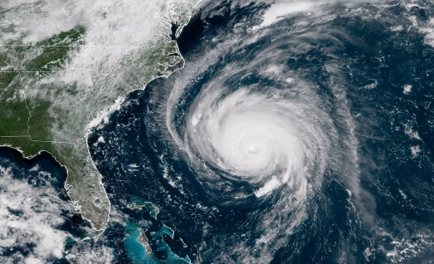
The federal law designating radio and TV as "first informers" during emergencies will be put to the test as Hurricane Florence makes its way to land. The National Association of Broadcasters has secured letters from the Department of Homeland Security to help prevent potential hurdles if local officials are unaware of the new law, which is designed to help ease the coverage path for broadcasters.
Inside Radio 9/13/18
http://www.insideradio.com/free/florence-brings-first-test-of-radio-s-first-informer-status/article_f9a1c33a-b729-11e8-9e72-db26f128b64c.html
Image credit:
https://timedotcom.files.wordpress.com/2018/09/hurricane-florence1.jpg

