Five Ways Social Media Is Changing PR
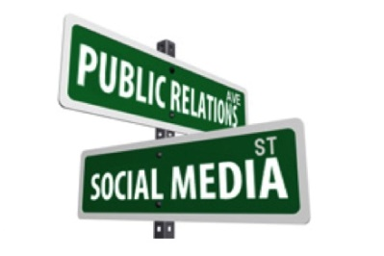
Facebook, Instagram, Twitter, YouTube and other social media channels have transformed the communication between companies and the public. The PR process used to be surprisingly one dimensional, but the future of PR is a conglomeration, with a focus on leveraging new innovations to communicate with the public. In the era of instant Twitter and Instagram feedback, companies now have customer service representatives fielding questions in real time via social media.
PR Week 6.10.19
https://www.earnedmediarising.com/?p=7019&utm_source=promo&utm_medium=email&utm_campaign=maropost_2703
Image credit:
https://prssaatlsu.files.wordpress.com/2014/02/screen-shot-2014-02-10-at-10-40-35-am.jpg

