Fixed Wireless Could Add 10 Million Subscribers By 2027
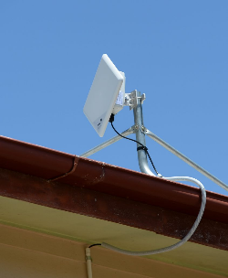
Fixed wireless access broadband could add more than 10 million subscribers in the next five years, driven by programs geared toward rural markets, according to a report by Wells Fargo telecom and media analysts Eric Luebchow and Steven Cahall.
Next TV/Multichannel News 5/20/22
https://www.nexttv.com/news/fixed-wireless-could-add-10-million-subscribers-by-2027-analysts-say?utm_source=SmartBrief&utm_medium=email&utm_campaign=C74FC4FA-5D4D-4151-8915-3043BA411DBE&utm_content=E0ED4DE3-7973-44B9-9093-B0BC4E704F31&utm_term=a25693a1-51b6-4112-bde4-56bd420e983f
Image credit:
https://media.apnarm.net.au/media/images/2013/10/24/9-2076073-rok231013cnbn7_t1880.jpg

