FM Radio Stations Thrive in the Age of the Internet
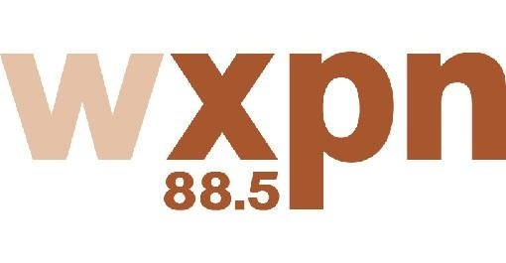
Some nonprofit FM stations, such as KEXP in Seattle and WXPN in Philadelphia, have continued to grow and thrive despite competition from streaming radio, observers say. Some local stations are using the Internet to expand their reach and discover new artists. "We barely call ourselves a radio station. We do so much more than that. We see ourselves as a media organization, a community organization," KEXP morning disc jockey John Richards says.
The New York Times 11/8/15
http://www.nytimes.com/2015/11/09/technology/in-the-stream-of-internet-radio-music-stations-hold-their-own.html?WT.mc_id=SmartBriefs-Newsletter&WT.mc_ev=click&_r=0

