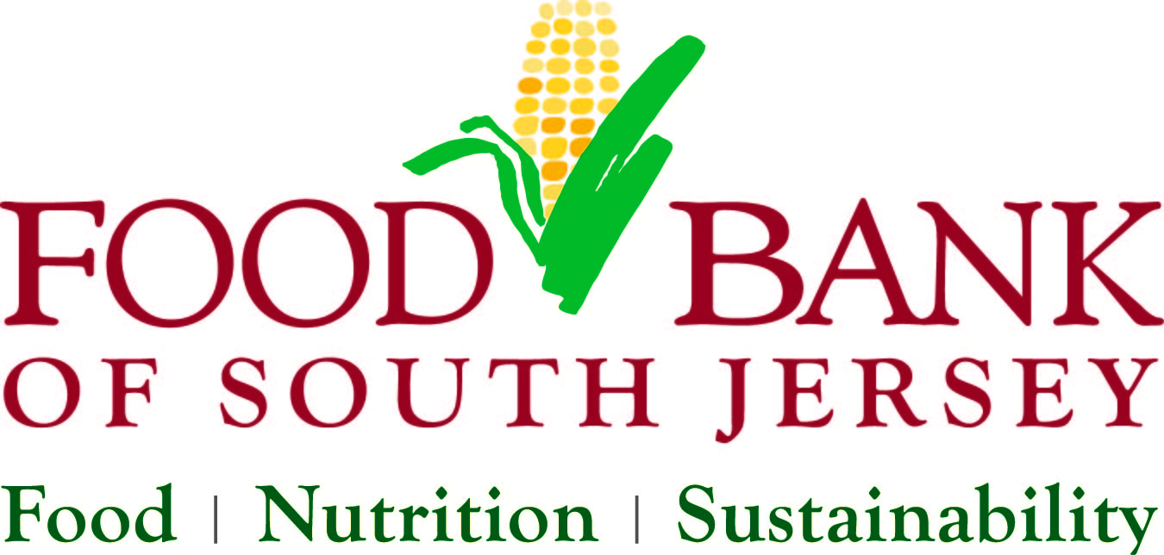
Public Relations/Marketing Intern
Job Description

Position: The Public Relations/Marketing Intern works directly with the Marketing and Fund Development Department assisting with marketing and public relations projects. This internship will support a wide range of initiatives throughout the organization, so the applicant must be an upbeat self-starter, organized and enjoy a fast-paced work environment. Public Relations/Marketing interns leave with a valuable experience for resumes and a professional portfolio.

Staff Contact: Yarissa Reyes, Director of Strategic Marketing and Business Development

Hours: Full and part-time internships are available each semester. Hours are flexible, but please be willing to work at least 16 hours a week for 12 weeks. Telework options are available. Preference will be given to candidates who can commit to a full year.

Compensation: Unpaid internship. Will work with intern to provide academic credit if applicable.

Responsibilities:
- Assist with marketing projects such as advertising campaigns and promotions
- Craft media pitches and media alerts
- Work with staff to create copy for website
- Assist with publishing email blasts
- Draft content for newsletters, press releases and articles
- Manage social media postings
- Manage special events (gala and Hunger Action Month) promotions
- Research and solicit media and corporate sponsorships and track progress

Skills Needed:
- Detail oriented, resourceful and creative
- Graphic design experience helpful
- Proficient in Microsoft Word, PowerPoint, Excel, Publisher and Outlook
- Excellent written and verbal communication skills
- AP Style knowledge a plus

Requirements:
- Must be currently enrolled in a communications program or related field;
or a recent graduate
- 3.0 GPA
- Communications/writing experience
- Must have own laptop

- The ideal candidates will be able to:
- Work independently within guidelines and ask for direction when new situations arise
- Work under tight deadlines and on multiple projects simultaneously, with minimum supervision
- Interact professionally with varying groups of people including Board members, staff, volunteers, donors and vendors
  - Accept supervision and mentoring while developing competencies to manage projects effectively

Application Instructions: Submit the following documents by e-mail, standard mail delivery or hand delivery to contact listed below.
- Internship Program Application
- Current resume and cover letter
- Two writing samples (ex. press release, newsletter, marketing piece, news article)

About The Food Bank of South Jersey
The Food Bank of South Jersey (FBSJ) is the leader in providing safe and nutritional food to people in need throughout South Jersey. FBSJ distributes food, provides nutrition education and cooking courses, and helps food insecure families and seniors find sustainable ways to improve their lives. To learn more visit www.foodbanksj.org.

Contact Information:

Yarissa Reyes
Director of Strategic Marketing & Business Development
Food Bank of South Jersey
1501 John Tipton Blvd.
Pennsauken, NJ 08110
Phone: 856-662-4884 Ext. 133
yreyes@foodbanksj.org

