For News Publishers, Smart Speakers Are the Hot New Platform
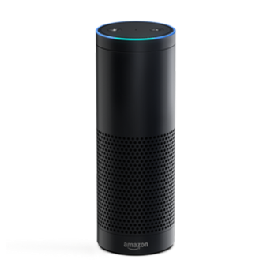
NPR has six people who are dedicated to voice assistants and is in the process of creating an editorial position that will be dedicated to them. The New York Times is advertising for a voice editor to help define the Times on voice-enabled devices. The person will be part of special projects and work on prototypes and the publication of its first set of voice experiences on these platforms, according to a job posting.
Digiday 7.23.18
https://digiday.com/media/news-publishers-smart-speakers-hot-new-platform/?utm_source=API+Need+to+Know+newsletter&utm_campaign=88709c794f-EMAIL_CAMPAIGN_2018_07_24_12_08&utm_medium=email&utm_term=0_e3bf78af04-88709c794f-31697553

