Former Facebook Exec Days Docial Media is Ripping Apart Society
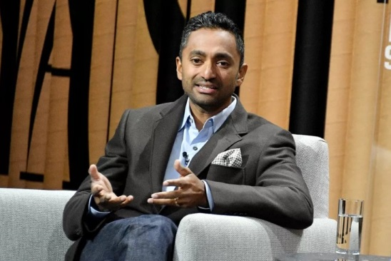
Chamath Palihapitiya, who joined Facebook in 2007 and became its vice president for user growth, said he feels “tremendous guilt” about the company he helped make. “The short-term, dopamine-driven feedback loops we’ve created are destroying how society works,” he said, referring to online interactions driven by “hearts, likes, thumbs-up.” “No civil discourse, no cooperation; misinformation, mistruth.
The Verge 12.11.17
https://www.theverge.com/2017/12/11/16761016/former-facebook-exec-ripping-apart-society
Image credit:
http://www.ent-redefined.org/wp-content/uploads/2017/12/Chamath-Palihapitiya-FORMER-FACEBOOK-EXEC.jpg

