Freedom of Expression Is At A Ten-Year Low, Study Says
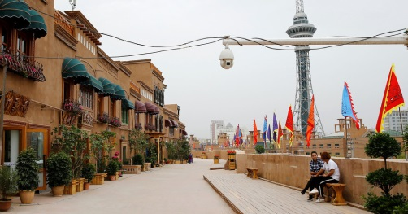
Governments in a number of countries have been increasing online surveillance and cracking down on content and behavior that indicates dissent, the report says. According to Article 19's analysis, more than 65 countries with a combined population of over 5 billion people have seen their freedom of expression decline over the past decade.
Article 19 12.2.19
https://www.article19.org/xpa-2019/?utm_source=CJR+Daily+News&utm_campaign=9d3c5e4a1a-EMAIL_CAMPAIGN_2018_10_31_05_02_COPY_01&utm_medium=email&utm_term=0_9c93f57676-9d3c5e4a1a-174383521
Image credit:
https://static01.nyt.com/images/2019/04/15/business/06daily1/06daily1-facebookJumbo-v2.jpg

