Frictionless ‘Stores of The Future’ Will Land and Expand
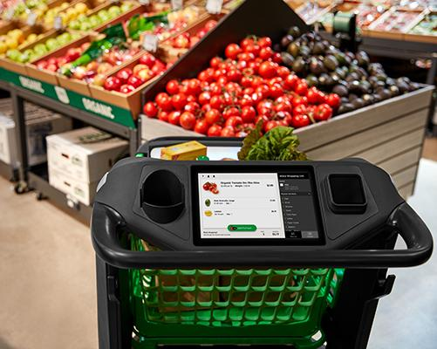
Amazon is rapidly advancing the technology and customer awareness of frictionless commerce. The rollout of Amazon Go, the cashierless convenience store concept featuring its patented Just Walk Out technology, is well underway. Now Amazon Fresh grocery stores, which feature “Dash Carts” that automatically scan and charge items placed in the shopping cart, are popping up near big cities like Los Angeles and Chicago.
eMarketer 3.18.21
https://www.emarketer.com/content/frictionless-stores-of-future-will-land-expand?ecid=NL1001
Webinar on topic:
https://emarketer.brand.live/c/10-trends-for-a-transforming-world
Image credit:
https://assets1.risnews.com/styles/content_sm/s3/2020-07/amazon%20dash%20cart%20Close%20Up%20Cart%20w%20Screen.jpg?itok=X3RCaZoX

