From East to West, Hundreds of Newspapers Run Pro-Press Editorials
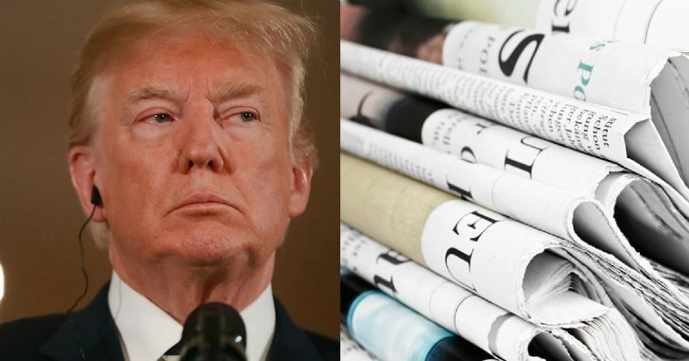
Approximately 350 newspapers nationwide are running editorials today that make bold statements about freedom of the press while denouncing President Donald Trump's anti-media rhetoric. Several TV and radio stations also are participating.
CNN 8/16/18
https://money.cnn.com/2018/08/15/media/newspaper-editorials-free-press-trump/index.html
Image credit:
https://media.indiatimes.in/media/facebook/2018/Aug/american_media_us_president_donald_trump_the_boston_globe_1534416242_800x420.jpg

