FTC Asked by Senators to Investigate Ad Fraud Issue
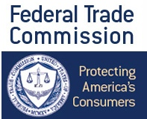
Democratic Sens. Chuck Schumer of New York and Mark Warner of Virginia are requesting that the Federal Trade Commission look at the problems surrounding bots in digital advertising. "It remains to be seen whether voluntary, market-based oversight is sufficient to protect consumers and advertisers from digital advertising fraud," they wrote in a letter.
Business Insider 7/12/16
http://www.businessinsider.com/heres-the-letter-2-us-senators-sent-urging-the-ftc-to-clamp-down-on-ad-fraud-2016-7

