FTC Considers Banning Facebook from App Integration
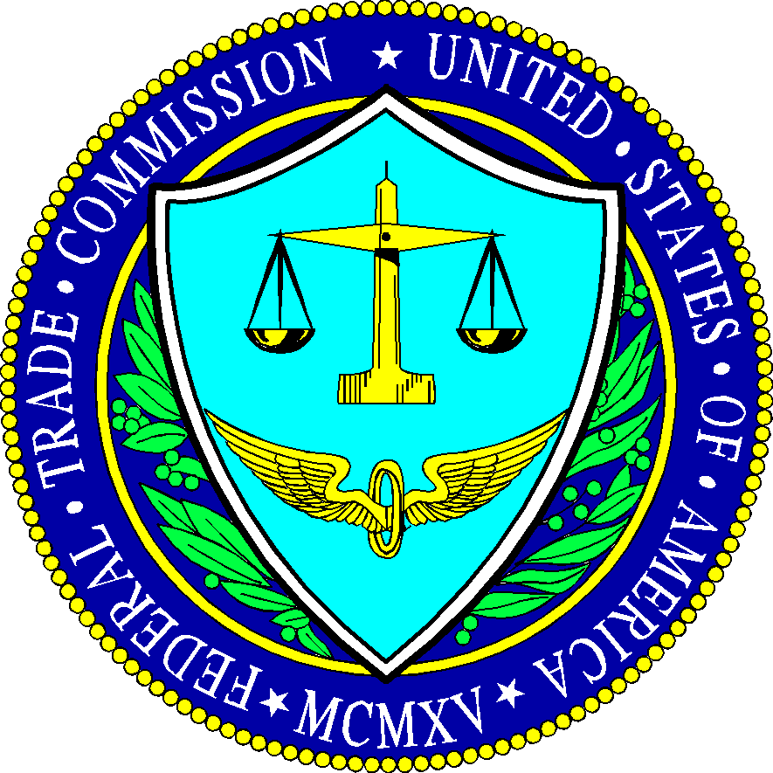
The Federal Trade Commission is reportedly considering imposing an injunction against Facebook that bans the social platform from integrating its family of apps -- including Instagram, Messenger and WhatsApp -- as part of its antitrust efforts, according to a Wall Street Journal report. The commission is making the move so that it maintains the ability to split the business in the future if it deems necessary, according to sources, and is also looking at the interoperability of Facebook's apps with competitors.
The Hill 12/12/19
https://thehill.com/policy/technology/474364-ftc-weighing-injunction-over-facebook-app-interaction-report

