FTC Sending Transparency Message to Instagram Influencers
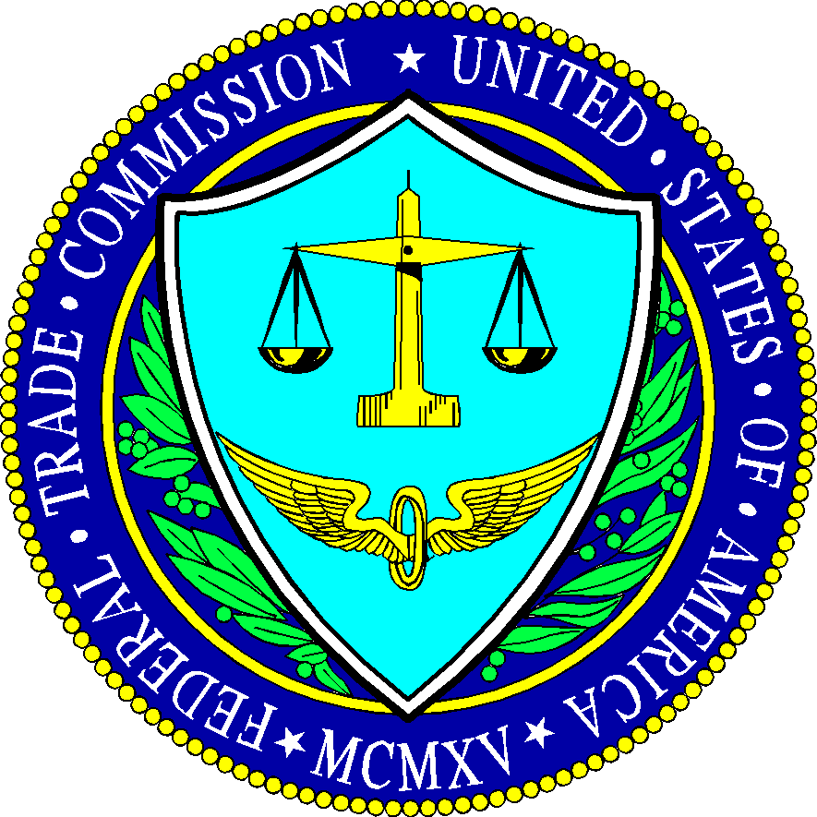
The Federal Trade Commission is contacting more than 90 Instagram influencers and marketers with a message of reinforcement regarding transparency in paid content. The FTC is also encouraging Instagram users to report content that they think skirts disclosure rules.
The Drum (Glasgow, Scotland) 4/20/17
http://www.thedrum.com/news/2017/04/20/instagram-influencers-riding-roughshod-over-sponsored-posts-rules

