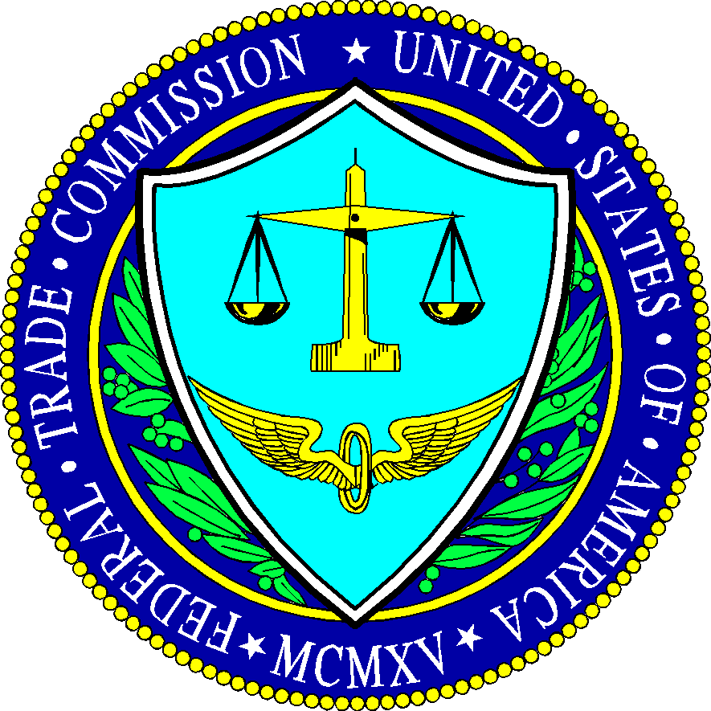
FTC Settles With Social Media 'Influencers'
Two social media influencers reached a settlement with the Federal Trade Commission, which claimed they endorsed a website without telling their fans they also owned the company.
Axios 9.8.17
https://www.axios.com/influencers-settle-ethics-charges-with-ftc-2482637528.html

