FTC to Tackle Privacy Concerns Raised by Smart TVs
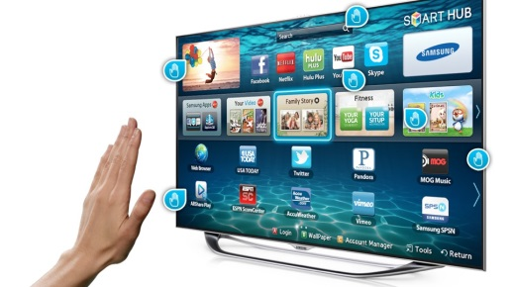
"In 2016, virtually all television delivery systems -- smart TVs, streaming devices, game consoles, apps, and even old-fashioned set-top boxes -- track consumers’ viewing habits, and sometimes in new and unexpected ways," the FTC stated on its Web site. Smart TV manufacturer Vizio is currently facing a federal lawsuit for allegedly sharing information about people's viewing histories with ad tech companies and data brokers.
MediaPost 4.4.16
http://www.mediapost.com/publications/article/272592/ftc-to-tackle-privacy-concerns-raised-by-smart-tvs.html

