AT&T Lays Out Limited Future for DIRECTV
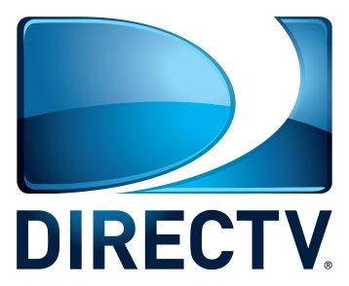
AT&T will restrict marketing for its DIRECTV satellite service to areas without widespread broadband access now that streaming platform AT&T TV is an option, Chief Operating Officer and President John Stankey told an investor conference. Stankey noted that AT&T, which bought DIRECTV in 2015, had anticipated satellite technology becoming obsolete by now.
Next TV 3.5.20
https://www.nexttv.com/news/atandts-stankey-directv-now-sold-only-in-places-where-cable-broadband-is-not-prevalent

