Ratings: Game Shows Don't Play Around
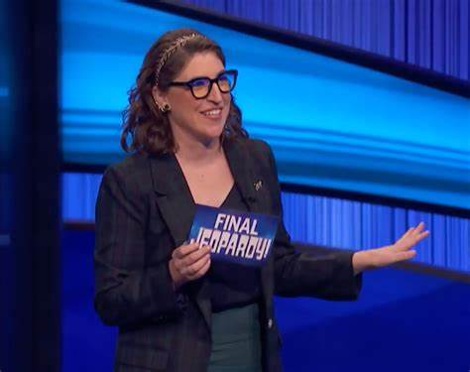
"Jeopardy!" "Family Feud" and "Wheel of Fortune," respectively, took the top three Nielsen slots for syndicated shows during the week that ended on March 1. "Judge Judy," the top court-themed show in syndication, held onto fourth place while "Live with Kelly and Ryan" remained fifth overall and number one for talk shows.
TVNewsCheck (free registration) 3/7/23
https://tvnewscheck.com/programming/article/game-shows-reign-supreme-in-syndication/
Image credit:
https://bestlifeonline.com/wp-content/uploads/sites/3/2023/03/mayim-bialik-jeopardy-copy.png

