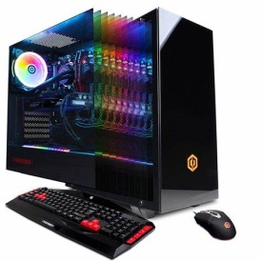
Gaming Developers Focus On Desktops And Laptops
More than 80% of video game developers worldwide were making games for PCs as of May 2022. For console and mobile games, that figure was closer to 40%.
eMarketer 10.11.22
https://www.insiderintelligence.com/content/gaming-developers-focus-on-desktops-laptops?IR=T&utm_source=Triggermail&utm_medium=email&utm_campaign=II20221012COTD&utm_content=Final&utm_term=COTD%20Active%20List
Image credit:
https://www.bing.com/images/search?view=detailV2&ccid=r8Gfmwak&id=ED73D1E2C17D7055675EC0FD46CC67001342151D&thid=OIP.r8GfmwakYEQ_k5NrQQLZPwHaHa&mediaurl=https%3a%2f%2fassets.vg247.com%2fcurrent%2f2019%2f03%2famazon-pc-gaming-deals-us.jpg&cdnurl=https%3a%2f%2fth.bing.com%2fth%2fid%2fR.afc19f9b06a460443f93936b4102d93f%3frik%3dHRVCEwBnzEb9wA%26pid%3dImgRaw%26r%3d0&exph=1500&expw=1500&q=gaming+desktop&simid=607997675464897182&FORM=IRPRST&ck=A8AA2CE78294CB7DDBFB794A0E9E1572&selectedIndex=66&ajaxhist=0&ajaxserp=0

