Mobile, Cross-Platform Key To Gaming's Future
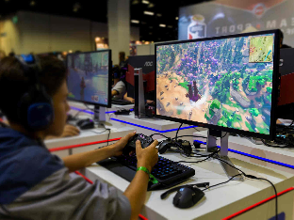
The mobile market is essential for gaming's growth, Microsoft Gaming leader Phil Spencer said in reference to the company's Activision Blizzard purchase. Analysts add that cross-platform titles, live gaming and cloud games are likely to be major parts of the industry going forward.
Protocol 11/1/22
https://www.protocol.com/entertainment/mobile-gaming-old-guard-necessity
Image credit:
https://www.notebookcheck.net/fileadmin/Notebooks/News/_nc3/Global_Shipments_of_Gaming_Monitors_AOC_IFA_2018.jpg

