Gawker's Legal Battle with Hulk Hogan Is Settled
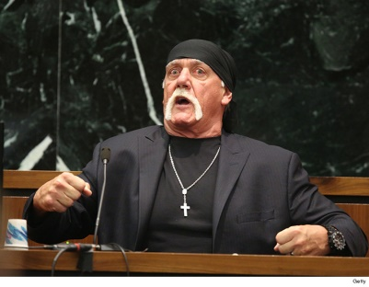
The company formerly known as Gawker Media has settled with Terry Bollea, who once went by the moniker Hulk Hogan. Mr. Bollea, in March, was awarded $115 million by a Florida jury in an invasion-of-privacy case that stemmed from Gawker.com, in 2012, publishing a short portion of a video of the ex-wrestler engaged in a sex act.
Advertising Age 11.2.16
http://adage.com/article/media/gawker-s-legal-battle-hulk-hogan-finally-settled/306591/?utm_source=mediaworks&utm_medium=newsletter&utm_campaign=adage&ttl=1478729151?utm_visit=113450

