Gaza "Citizen Journalists" Share Stories Amid The Crisis
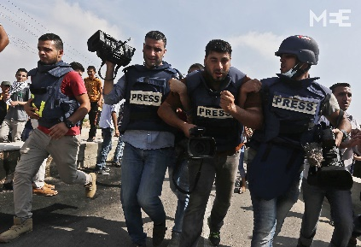
A number of young Gaza residents have turned into "citizen journalists" by using their social media following to share stories about their experiences amid the Israel-Gaza war. Foreign reporters can only access the region by embedding with the Israeli military, and many Palestinian journalists have been displaced or killed during the ongoing war.
The Guardian (London) 12/12/23
https://www.theguardian.com/world/2023/dec/12/gaza-citizen-journalists-war-footage-israel
Image copyright:
https://www.middleeasteye.net/sites/default/files/1_19.jpg

