Shocker: Millennials Aren’t Heaviest Social Media Users
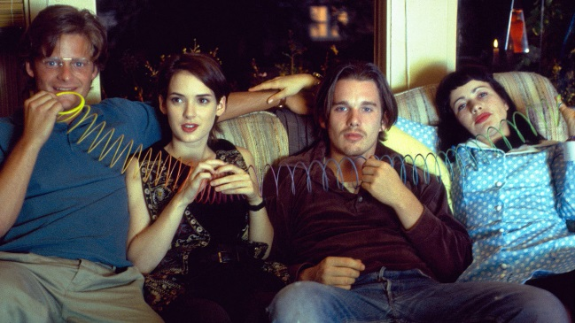
It's Gen X. Generation Xers, 37 to 52, spend six hours and 58 minutes on social media. That’s 10 percent more than Millennials. What’s more, Gen X increased its social media time by 29 percent from third quarter of 2015 to Q3 of 2016, while Millennials only increased by 21 percent. Those over 50 had the biggest gain, at 64 percent.
MediaLife 1.19.17
http://www.medialifemagazine.com/millennials-not-heaviest-social-media-users/
Image source:
http://assets.nylon.com/system/featured_images/attachments/000/007/869/original/reality-bites.jpg?1413929673

