Gen Y, Gen Z Spending More Time on YouTube, Social
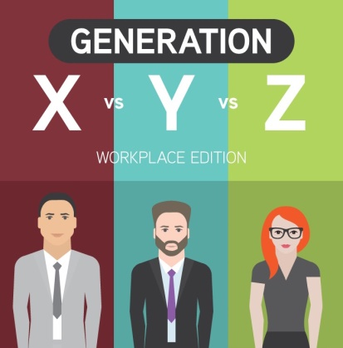
Some 59% of Generation Z Americans use YouTube more now than they did in 2017, 56% spend more time on Snapchat and 55% use Instagram more often, per a VidMob study. Millennial respondents also have increased use, with half saying they use Instagram more, 46% spending more time on YouTube and 40% increasing their use of Snapchat.
eMarketer 9/26/18
https://www.emarketer.com/content/more-millennials-gen-z-are-using-social-apps
Image credit:
https://venngage-wordpress-gallery.s3.amazonaws.com/uploads/2016/08/Generation-X-vs-Generation-Y-vs-Generation-Z-Cropped-1.jpg

