Gender Gap Closing in the American Film Market
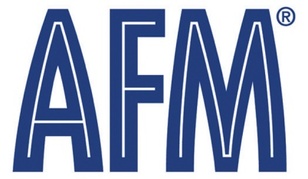
The American Film Market is closing its gender gap as more high-profile female roles meet demand from female movie-goers. "It's a real trend," says IM Global CEO Stuart Ford. "The traditional male-oriented feature, the $35 million action movie with Jason Statham, Gerald Butler or Nicolas Cage -- that business is sort of dead now because it's a very risky proposition. Distributors are looking for movies that can play equally well male-female or that are female-centric."
The Hollywood Reporter 11/3/16
http://www.hollywoodreporter.com/news/afm-2016-why-female-centric-films-outnumber-male-skewing-action-movies-943781

