Fuse: Gender Inclusivity Should be Visible in Brand Campaigns
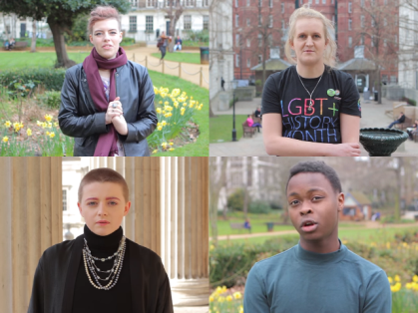
Marketing agency Fuse's new whitepaper underscores the importance of visible gender inclusivity to Gen Z in ads -- an initiative that has been adopted by several brand campaigns, including Harry's Shave Company and Calvin Klein. A recent study by the Geena Davis Institute on Gender in Media and Google detailed how gender parity in brand videos bolsters viewing on digital platforms like YouTube by 30%.
Yahoo/PRNewswire 3.27.20
https://finance.yahoo.com/news/brands-know-gender-inclusion-road-150000174.html
Image credit:
http://media.breitbart.com/media/2016/09/UCL-THEY-THEM.png

