Google Adding More News Content to ‘Top Stories’ in Search Results
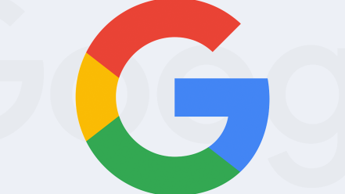
Users will now see multiple carousels of news stories. When people search for news, they typically see two top stories and a horizontal, scrolling carousel of results (AMP pages). As of today on mobile devices, people will see multiple carousels of news stories on the same topic. They’ll also find additional content types, “such as notable quotes and related opinion pieces,” according to a Google blog post.
Search Engine Land 12.11.19
https://searchengineland.com/google-adding-more-news-content-to-top-stories-in-search-results-326272?utm_source=API+Need+to+Know+newsletter&utm_campaign=0c8719d7e4-EMAIL_CAMPAIGN_2019_12_12_01_10&utm_medium=email&utm_term=0_e3bf78af04-0c8719d7e4-31697553

