Google Initiative Helps Bring Local News Back In Ohio Town
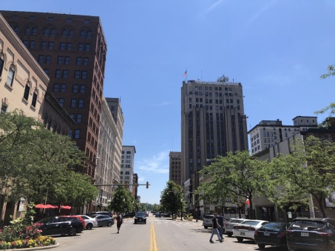
Youngstown, Ohio, will have local news coverage again following an announcement that McClatchy will create a local digital outlet as part of a Google-backed initiative known as "The Compass Experiment." A growing number of tech companies, donors and advocates are stepping up to address the decline of local news organizations.
Axios 7/18/19
https://www.axios.com/local-news-deserts-are-getting-some-relief-cf06dfee-5b23-4116-a8b6-346e89655422.html
Image credit:
https://miro.medium.com/max/1000/1*EC7fJYi-kdw3APPhXtwCog.jpeg

