Google Plans Image-Search Ads for Mobile Shopping
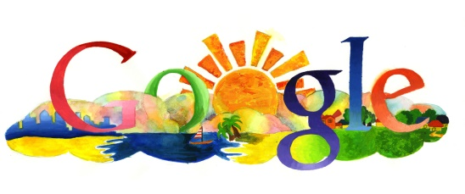
Google plans to start showing ads in mobile image searches while also giving users the ability to sort products by features such as color and type. The company says the feature will make it easier for people to shop via smartphone, noting that image search users' top questions already center on shopping.
Business Insider 5/16/16
http://www.businessinsider.in/Get-ready-to-start-seeing-ads-in-Google-Image-search/articleshow/52298159.cms

