Google Vows to Tackle Ad-Placement Controversy as Brands Cut Ads
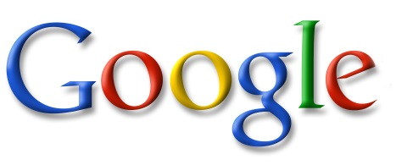
Google has promised to boost its efforts to give advertisers more control over where ads appear after the boycott of ads on its platform by The Guardian, the UK government, L'Oreal and Havas Media Group UK. Google says changes are going to be made immediately to help advertisers prevent ads from being displayed on questionable sites or alongside offensive videos.
Bloomberg 3/17/17
https://www.bloomberg.com/news/articles/2017-03-17/u-k-pulls-ads-from-youtube-citing-failures-in-policing-content

