Gov. Spying On Journalists to Find Leakers
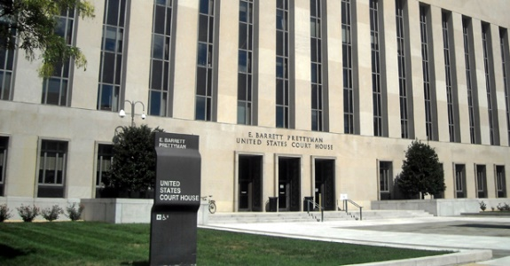
The Justice Department has gotten a warrant from the US Foreign Intelligence Surveillance Court — also known as the FISA court — to conduct electronic surveillance on a group of journalists who’ve been the recipient of leaked information.
New York Post 6.2.17
http://nypost.com/2017/05/31/the-government-is-spying-on-journalists-to-find-leakers/
image credit:
http://3.bp.blogspot.com/-FRXklrwfiMM/UhV7iQiRyUI/AAAAAAAAOhQ/JMNMagPFaHI/s1600/FISA++court.jpg

