Gray Closes On $3.6 Billion Raycom Merger
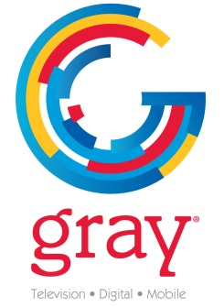
In wrapping up its $3.6 billion purchase of Raycom Media, it expands its footprint to 91 markets and 24% of TV homes. In connection with the merger, Gray and Raycom also completed the divestitures of nine stations in overlap markets to Tegna, Scripps and Lockwood.
TVNewsCheck 1.2.19
https://tvnewscheck.com/article/top-news/227754/gray-closes-3-6-billion-raycom-merger/?utm_source=Listrak&utm_medium=Email&utm_term=Gray+Closes+On+%243.6+Billion+Raycom+Merger&utm_campaign=Gray%2c+Tegna%2c+Scripps+Close+On+Station+Buys

