Gray to Buy Raycom for $3.6 Billion
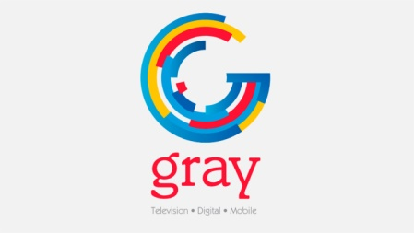
The combined company, after spinning off nine stations, will operate 142 stations in 92 markets with a U.S. coverage of 24%. The transaction marks Gray’s transformation from a small, regional broadcaster into a major media company with nationwide scale.
TV NewsCheck 6.25.18
www.tvnewscheck.com/article/114556/gray-to-buy-raycom-for-36-billion?utm_source=Listrak&utm_medium=Email&utm_term=Gray+To+Buy+Raycom+For+%243.6+Billion&utm_campaign=Gray+To+Buy+Raycom+For+%243.6+Billion

