Guard Your Freedoms: Legislatures in Session
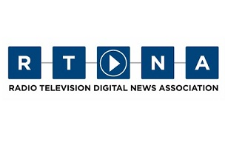
As state legislatures convene for their 2016 sessions, there are proposals for bills that impact journalists and the public’s right to know. Some are dangerous, like those that would restrict access to police records and videos or hamper recording of police actions. Some, though, are downright silly. But they, too, bear mentioning and watching.
RTDNA 1.21.16
http://rtdna.org/article/guard_your_freedoms_legislatures_are_in_session

