Half of 2018-2019 TV Shows Directed by Women, Minorities
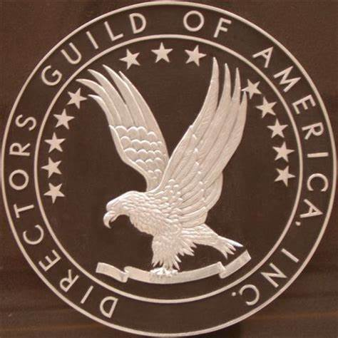
A recent report by the Directors Guild of America shows that women and minorities in television made some headway this year by directing half of the 4,300 episodes produced, up from last season's 42.5%. The study also concluded that though these groups made professional strides, over half of these jobs did go to "perk" hires already affiliated with their shows, a hindrance for career advancement.
Deadline Hollywood 11/19/19
https://deadline.com/2019/11/dga-report-female-minority-episodic-tv-directors-have-another-record-year-direct-half-of-all-shows-for-first-time-ever-1202789379/

