Hillary Clinton Pushes Branded Back-to-School Gear
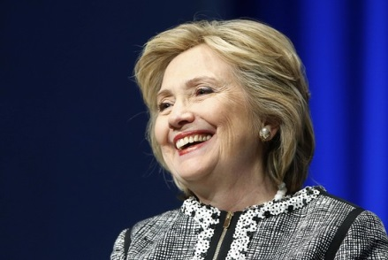
Democratic presidential frontrunner Hillary Clinton is pushing her gear, including backpacks, bottle openers and plastic cups, to college students as they prepare to return to campus. Other presidential hopefuls, including Republican candidates Rand Paul and Donald Trump, are also using e-commerce to generate buzz among young people.
Advertising Age 8.19.15
http://adage.com/article/cmo-strategy/hillary-clinton-pushes-back-school-collection-college-students/300010/?utm_source=daily_email&utm_medium=newsletter&utm_campaign=adage&ttl=1440553730

