Droga5, Amazon Music Celebrate 50 Years Of Hip-Hop
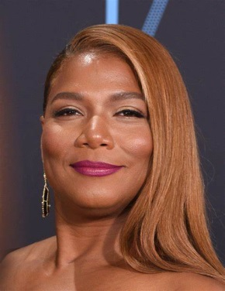
Amazon Music is marking hip-hop's 50th anniversary with a "50 & Forever" campaign including new music, playlists, events and original content such as livestreams spanning several platforms. A "Generational Queens" spot from Droga5 and director Fenn O'Meally tells the story of two teenage daughters discovering a new side to their mom when they find an old box containing mementos from her youth, including a cassette tape of Queen Latifah's "U.N.I.T.Y."
Muse by Clio 4.4.23
https://musebycl.io/music/amazon-music-celebrates-hip-hops-50th-birthday-iconic-queen-latifah-track
Image credit:
http://www.blackfilm.com/read/wp-content/uploads/2018/02/Queen-Latifah-pic.jpg

